|  |  |  |  |  |  |
| --- | --- | --- | --- | --- | --- |
| Date | Oct 6, 2022 | | | Tester Name | Alyssa Johnson |
| Environment | Penfax - Test | | | Login used |  |
| Operating System | Select OS | Version: | Update: | | |
| Software Used | Select Software | Version: | Update: | | |
| Select Software | Version: | Update: | | |
| Release version | 22.3.0 | | | | |
| Title | E23.14 | | | | |
| Test Type | Regression | | | | |
| Test Scenario | Payment to non-members | | | | |
|  |  | | | | |
| Expected Results | Verify the batch run successfully and letters generated and saved on member communications.  Must have payments such as:   * an ex-spouse (DC SRB payment) payment * death benefit payment to beneficiaries (perform payments for both spousal beneficiaries and non-spousal beneficiaries) | | | | |
| Pass/Fail | Pass | | | JIRA# | N/A |

Payments Processed for:

Death – 128467

SRB – 155821

Wait for overnight batch:

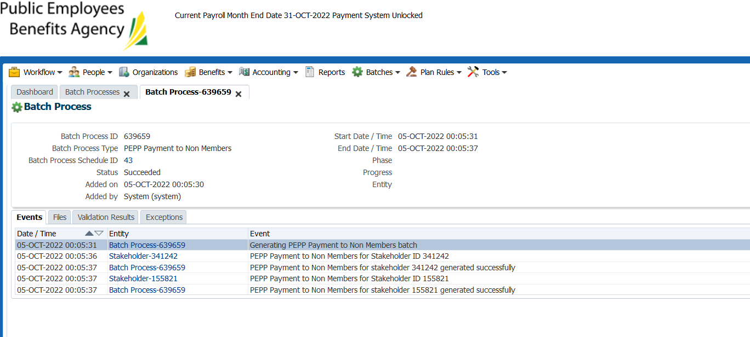

Letters generated for both members

The correct letter type is generated (death vs. interspousal)

No batch letter for this letter type (compared against production – same there)

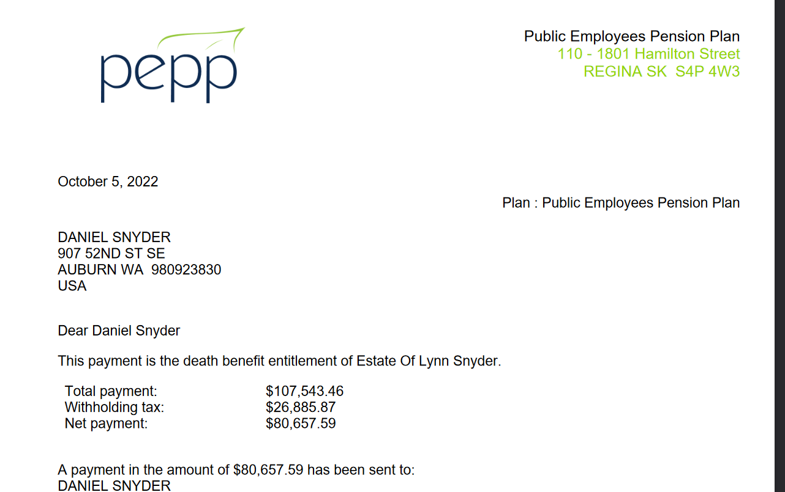

Shows under stakeholder’s communications tab:

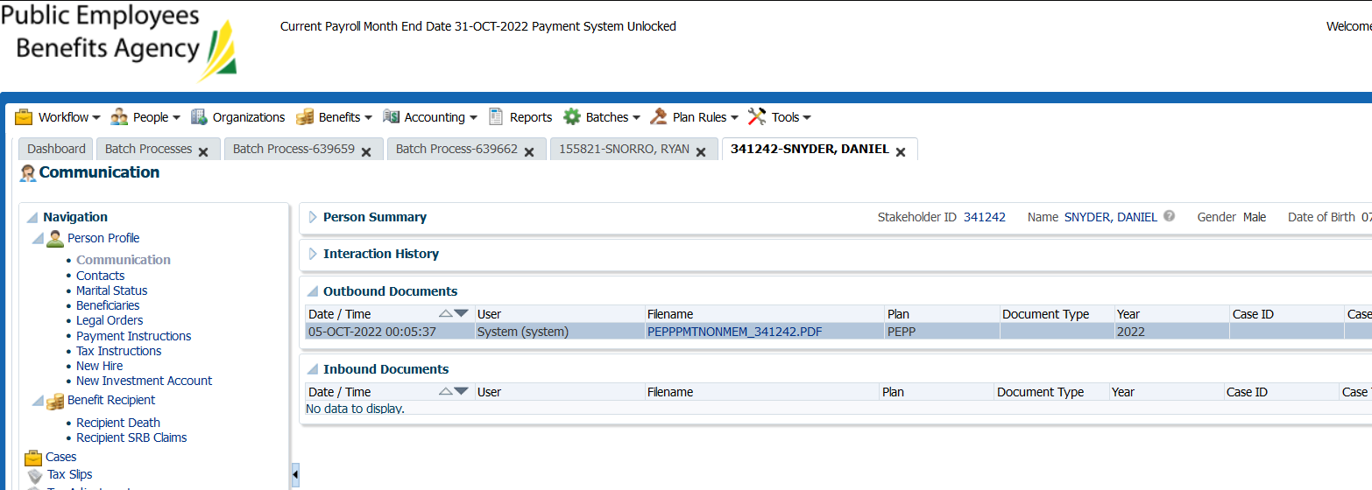

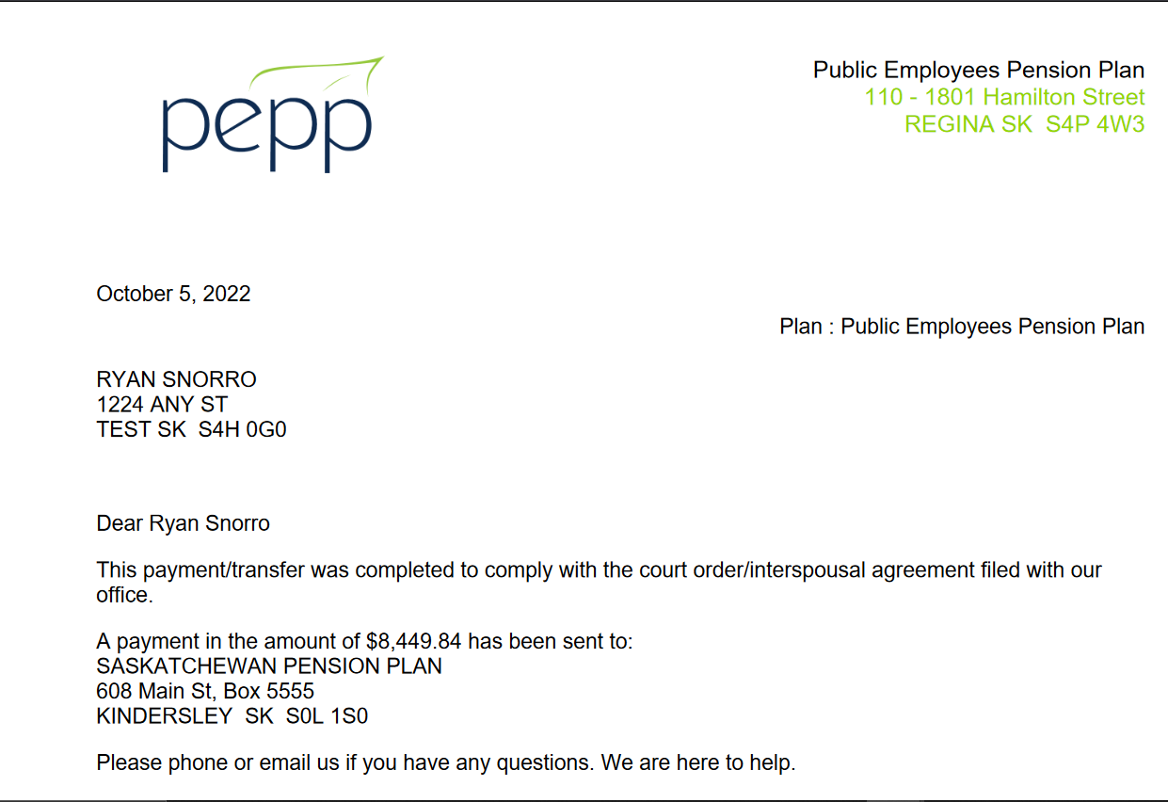

Letter shows in stakeholder communications tab (no PlaNet for Non-members)

